PSFML Worksheet (Ungraded practical Work)
- A box contains 10 ICs, one of them is defective. They are being tested one by one. If the IC is found to be good, it is placed in a separate box, and if it is bad then it is thrown away. Find the probability the defective IC is found in the first 4 trials. (Use basic conditional probability).

- Given the discrete CDF shown; find the probabilities;
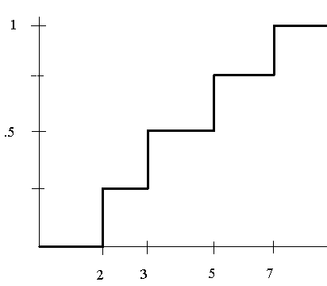
  - P(x = 7)

  - P(x = 3)

  - P(x < 4)

  - P(x >= 2.5)

- For the following graphs, state which of the following graphs resembles a valid (discrete) CDF and which doesn’t. Justify!
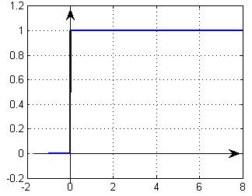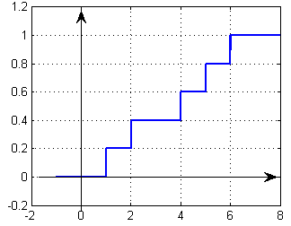
Figure a Figure b
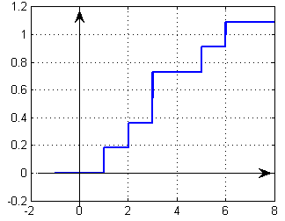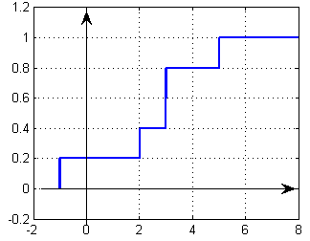
Figure c Figure d

- If X is an RV with Gaussian distribution with mean m = 1 and standard deviation σ = 2, find the probability that; (normal distribution, use the 68 95 99 rule)
  - X > 1
  - X = 1
  - -1 < X < 3
  - 1 < X < 3
  - X < -5
  - X > -3

- Consider two random variables X and Y with joint PMF given
- Find P(X=0,Y≤1).
- Find the marginal PMFs of X and Y.
- Find P(Y=1|X=0).
- Are X and Y independent?
- Let X be a discrete random variable with the following PMF below. Find and plot the CDF of X.
- Let X be a discrete random variable with PMF. Define Y=X(X−1)(X−2). Find the PMF of Y.
- For an experiment of rolling two dice. You observe two random variables X and Y which are the dice roll value for the first and second die respectively:
- Write down the outcome space of each random variable $S_{X}$ and $S_{Y}$.
- Find P(X = 2, Y = 6)
- Find (X>3|Y = 2)
- Let Z be a random variable that Z = X + Y. Find $S_{Z}$ and the PMF of Z.
- Find P(X=4|Z = 8)

- Let X be a discrete random variable with the following PMF
I define a new random variable Y as Y=(X+1)².
- Find the range of Y.
- Find the PMF of Y.

- The number of customers arriving at a grocery store is a Poisson random variable. On average 10 customers arrive per hour. Let X be the number of customers arriving from 10am to 11:30am. What is P(10<X≤15)?
- If X∼Poisson(λ), find Var(X).
- Let X be a continuous random variable with the following PDF
where c is a positive constant.
- Find c.
- Find the CDF of X, FX(x).
- Find P(1<X<3).
- Let X∼Uniform(−1,1) and Y=X². Find the CDF and PDF of Y.
- Suppose that the time between emergency calls to a small suburban fire station follows an exponential distribution with an average rate of 1.8 calls per day.
- Phil the fireman has just clocked on. What is the chance of a call in the next 15 minutes?
- Phil has nearly finished his shift: 15 minutes to go. There has been no call during his shift so far. What is the chance of a call in the next 15 minutes?
- Judy works a 10-hour shift, Mondays to Thursdays. What is the probability that she has no calls in a shift?
- What is the probability that she has no calls in four successive days?
- Judy is talking about her job: ‘In 10% of shifts, there’s a call in the first x hours of the shift.’ What is x, to one decimal place?
- Suppose that the difference between the forecast maximum temperature and the actual maximum temperature (in degrees Celsius) in a city is Normally distributed with mean 0 and standard deviation 1.2.
- Find the probability that the actual maximum is within 1.0 degrees of the forecast maximum.
- Which is more likely: an underestimate of 0.5 degrees or more, or a forecast within 0.5 degrees of the actual maximum?
- To evaluate a new test for detecting Hansen’s disease, a group of people 5% of which are known to have Hansen’s disease are tested. The test finds Hansen’s disease among 98% of those with the disease and 3% of those who don’t. What is the probability that someone testing positive for Hansen’s disease under this new test actually has it?

